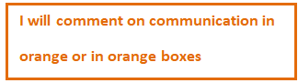

Aaron Bruce Smith.

Abs247.

MU123

TMA 03 2021J

Question 1

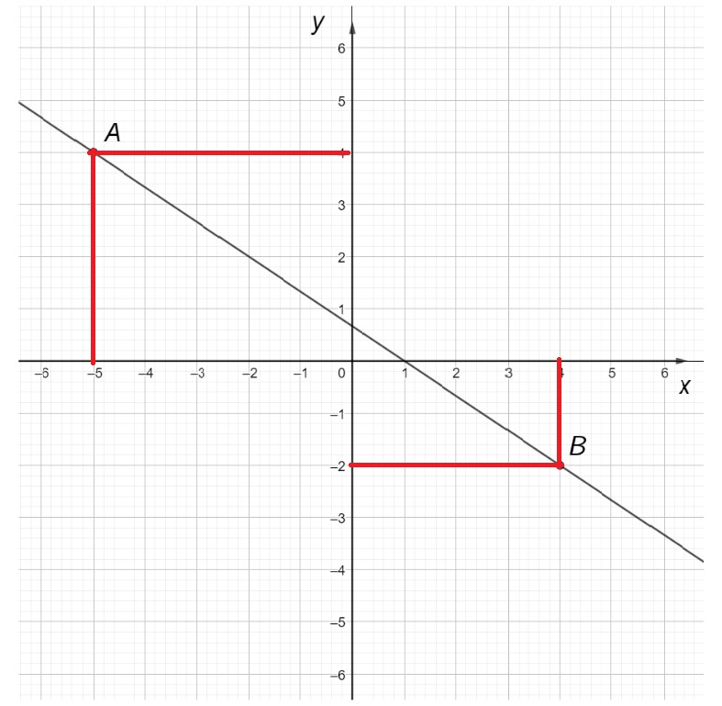

(a)

1. The coordinates of the graph (as above):

Point A: (-5, 4)



Point B: (4, -2)

1. The gradient of the slope.

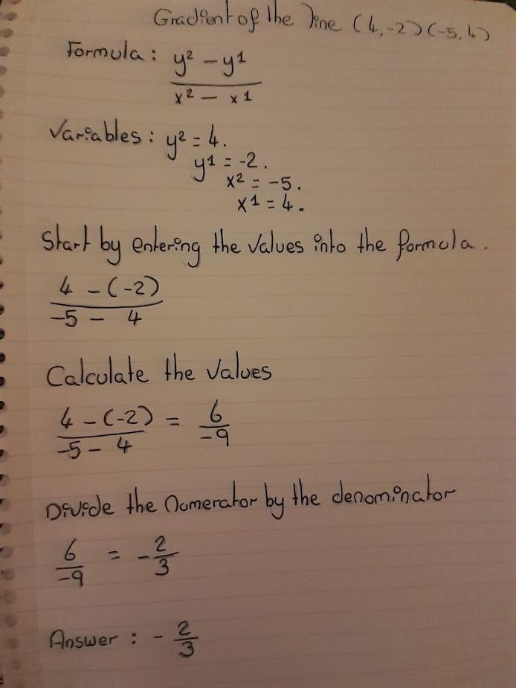

m =

Start with WHAT you

are finding a value for

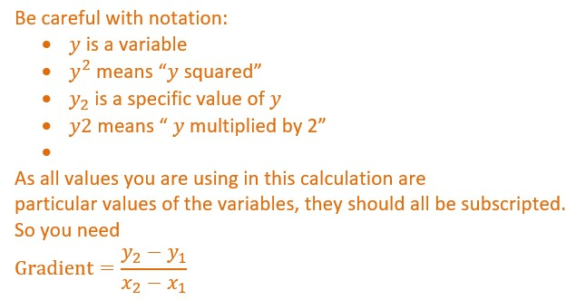

m =

m =

m =

Never write "Answer", as

it tells us nothing about

what this represents. You

need "The gradient of the

line is"

You have written a series of

unexplained sums, as you

haven't started with WHAT you

are finding a value for.

Best practice is to link equal

quantities with equals signs

rather than describing what you

are going to do.



Better:

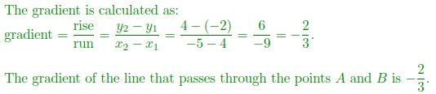

 (b)

i)

(

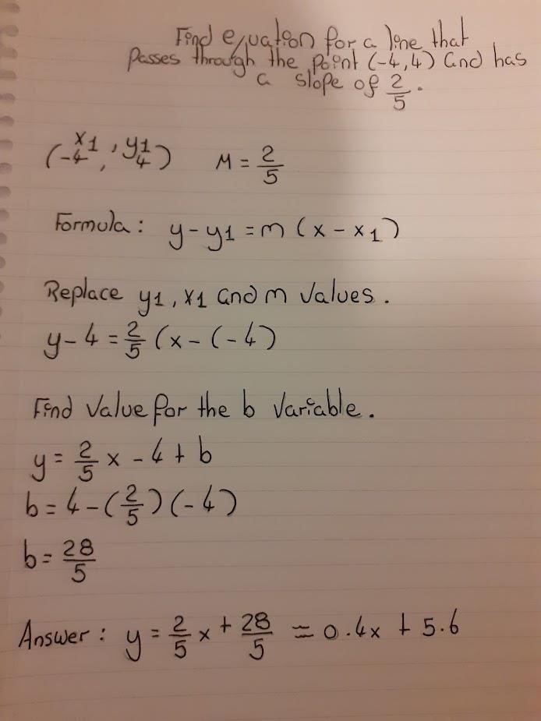

and

the equation of a straight line is given by

Rather than writing

"formula", it is

better to say what

the formula

represents



This form is preferable

The equation of the line is

Please try to write the

variable

*x*

as

*x*

and not x,

so we don't get confused

with a multiplication sign.



|  |
| --- |
| 1 mark for conclusion, but I can't tell how you got here. The correct method is to substitute the value of *x* into the equation, find the corresponding value of y and then compare with the given y coordinate.  [See Unit 6, p.80, Example 2; p.81, Activity 2] |

(ii)

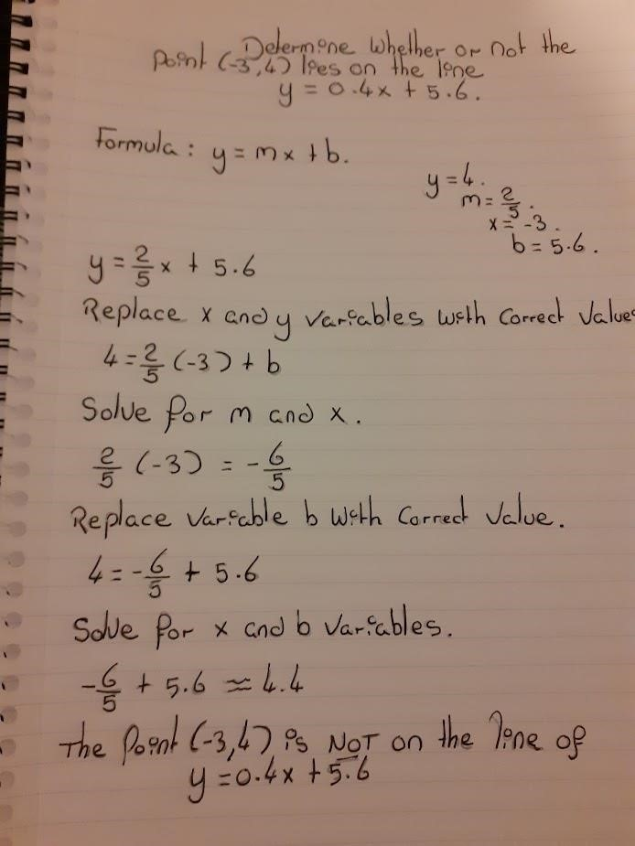

I'm not entirely sure what you are

doing. Not what you say you are

doing, particularly when you say

"solve for m and

*x*

", which means

"find values for m and

*x*

".

This is not the correct method, and

seems rather complicated.



How can you solve for m,

*x*

, and b when you seem

to already have values for

them?



Page **8** of **87**

(iii)

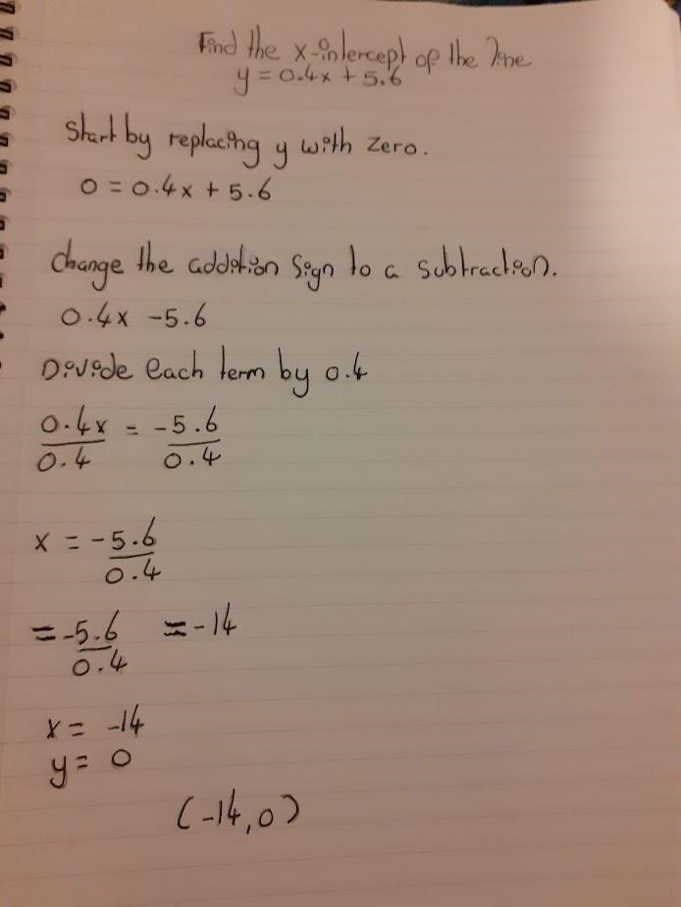

Do not think about "changing signs", as

this is not what you are doing. You are

subtracting 5.6 FROM BOTH sides of

the equation. Always think about what

you are doing to both sides.

=

*x*

So, the

*x*

-

intercept is

Therefore

when

Tell us what these

coordinates represent.

This is unexplained



Page Blank for Tutor Comments.

Page **10** of **87**

Question 2

(a)

(i) Foremost: an outlier is an abnormal point (value) on a graph which emanates erratically from other points (values) on the same graph.

Below is an example of an outlier on a graph.

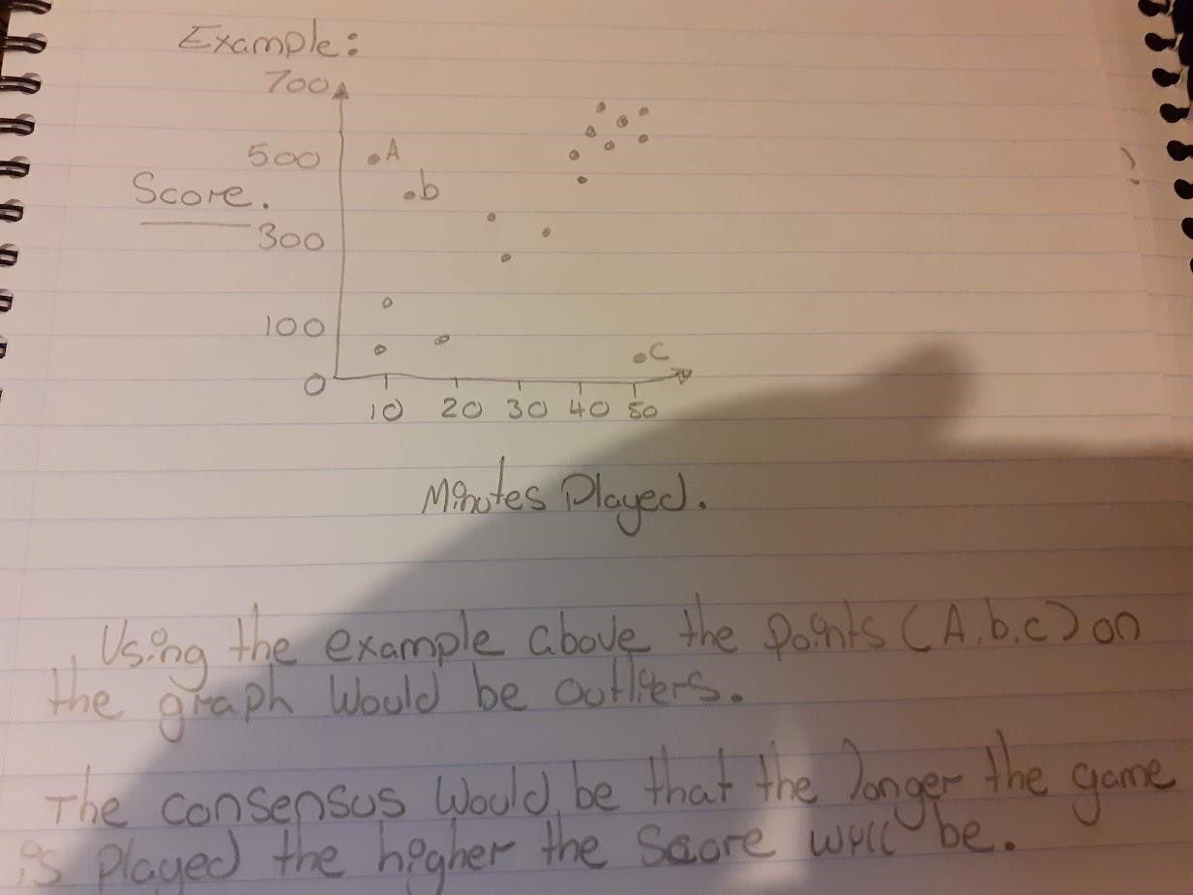

Ergo I would ask myself is there any data points that are placed in strange positions within the scatter plot that doesn’t fit the model very well? Moreover, I would want to see if a particular value stands out and then to try to understand why they might differ from the ordinary pattern in the data.

|  |
| --- |
| You are not being asked to give a reason for an outlier though - just what it would look like on the graph.  A potential outlier is a point that does not seem to follow the pattern of the rest of the distribution.  The above sentence is sufficient to answer this question. Note that we need the word 'potential' here, as we can't be certain that it really is an outlier. |

Page Blank for Tutor Comments.

Page **12** of **87**

(ii)

If x and y have a negative correlation as x increases in value y will decrease similarly if x decreases in value y will increase. Moreover, the higher the negative correlation between two variables the closer the correlation coefficient will be to the value -1.

So, you are saying that the data points would roughly fit a straight line with negative

gradient?Note that you are not being asked about the correlation coefficient. We are justinterested in how the points look on the graph.



(iii)

|  |
| --- |
| with a positive gradient. (-0.5 mark for not mentioning this) |

If r = 0.9 that would indicate a positive strong (strong: because the number 0.9 is very close to 1) correlation relationship between the variables on the scatterplot. It would also indicate that the data points are close (scattered around the data points) to the regression line.

We can see from the image below (img: 1.0) that there is a positive strong correlation coefficient.



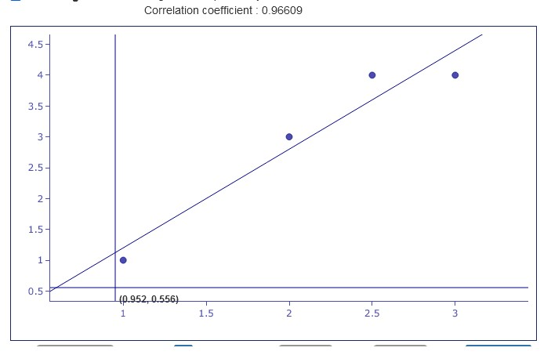

[img: 1.0]

(b)

(i)

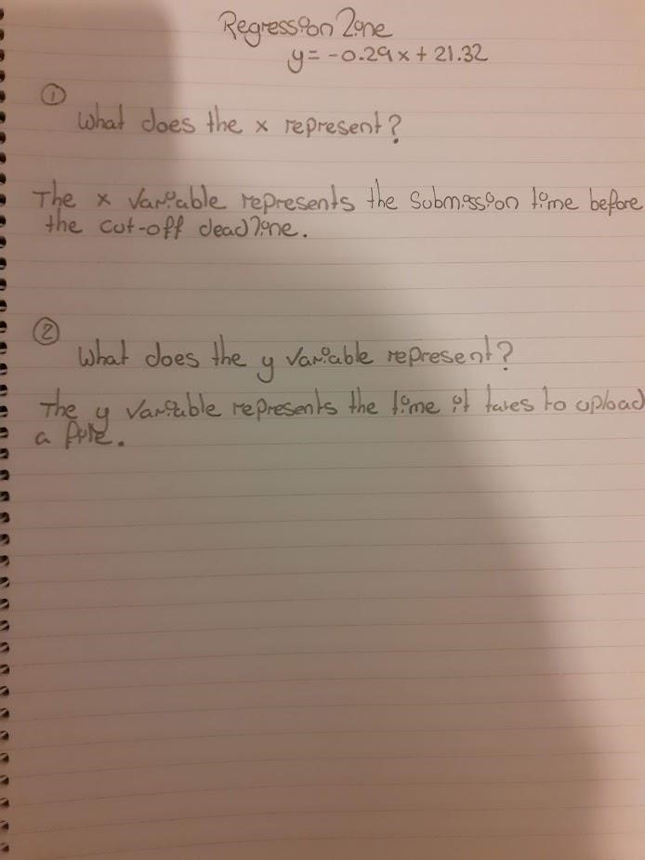

in minutes.

(-0.5

)

mark

in seconds. (-0.5 mark)



Page Blank for Tutor Comments.

Page **16** of **87**

(ii) If the value is -0.92 this would indicate a strong negative correlation between x and y because the number is very near 1.

-1. But I will give you the benefit of the doubt the time of submission

and the time taken to upload the file



(iii)

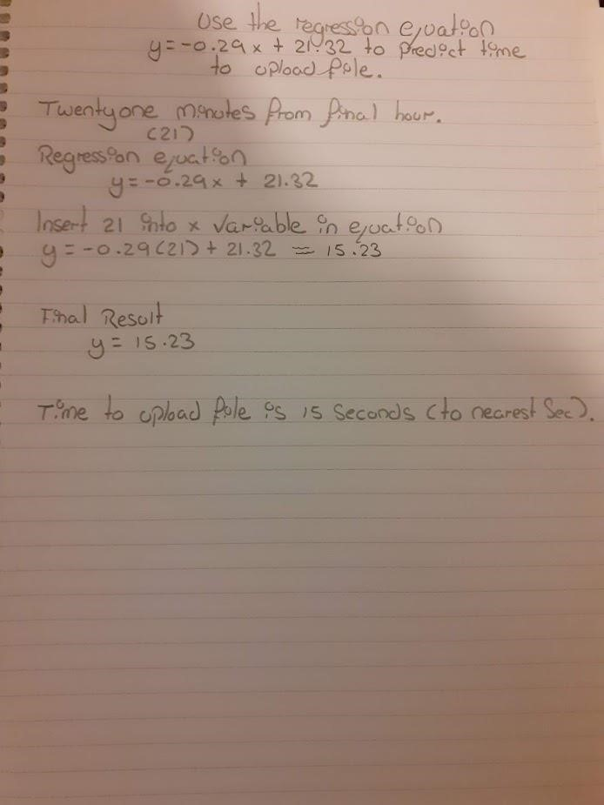

Page **18** of **87**

Page Blank for Tutor Comments.

(iv)

Page

**20**

of

**87**

When the

(

submission time

)

minutes from the hour (value) increases; the

time to upload the file decreases. This is evidence that the time will change

and speed up the closer to the submission time.

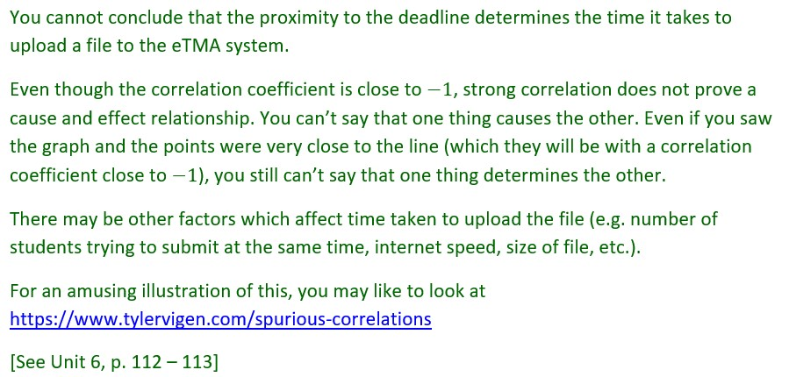

Page Blank for Tutor Comments.

Question 3

(a)

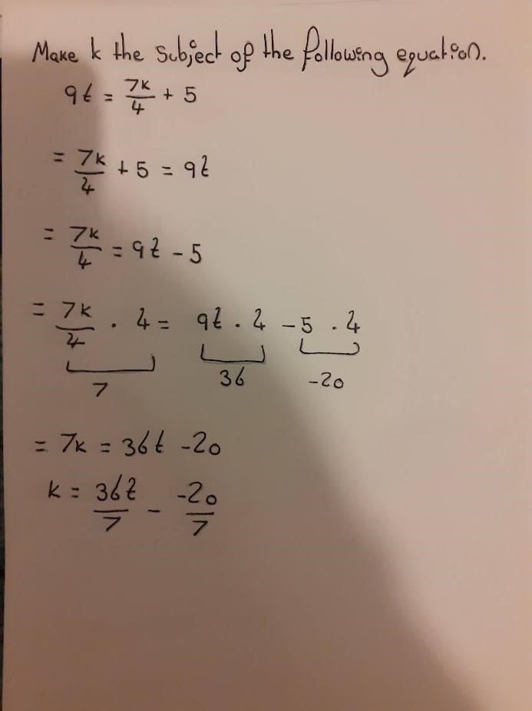

Please do not use a

dot for multiplication. It

is easily mistaken for a

decimal point

Misuse of equals sign. It is

incorrect to start an equation

with an equals sign. Equals

signs are for linking equal

expressions.

You have two minus

signs here, which

would result in a plus.

This is incorrect.

(-0.5

mark

)



Slightly better layout:

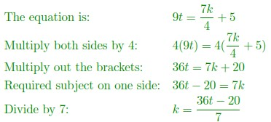

b)

(

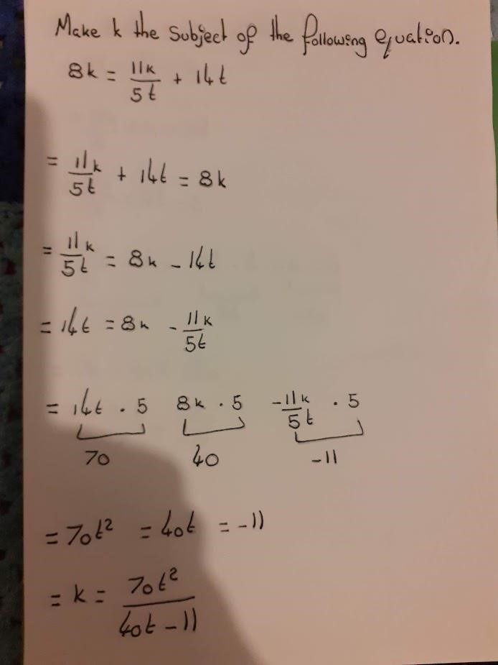

You seem to be saying that you

are multiplying through by 5 here.

But your next line demonstrates

that you actually multiplied

through by 5

*t*

on the LHS, but 5

on the RHS. You need to do the

same thing to both sides.

Spurious equals sign

Where has k gone in

this equation?

There is no indication of how you got to this final

result. It is correct, but doesn't follow from your

working.

1

mark for answer only.

See next page for correct solution.

40

*kt*

-11

*t*





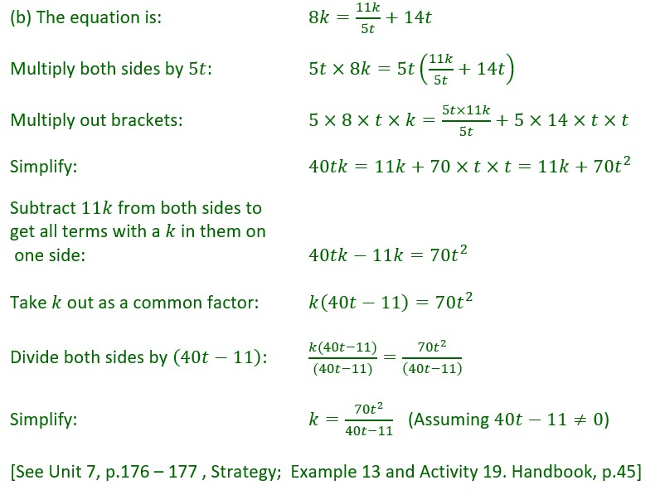

Question 4 (a)

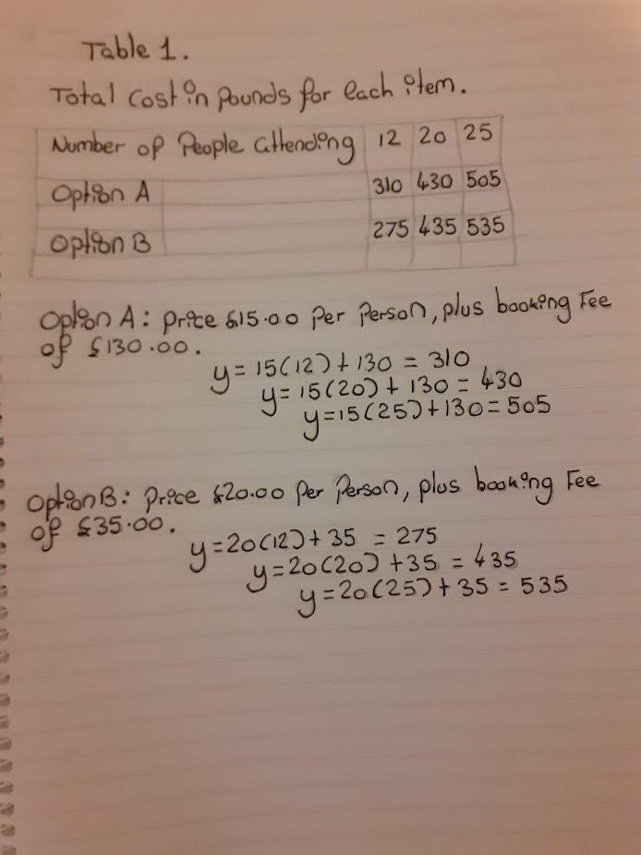

b)

(

i)

(

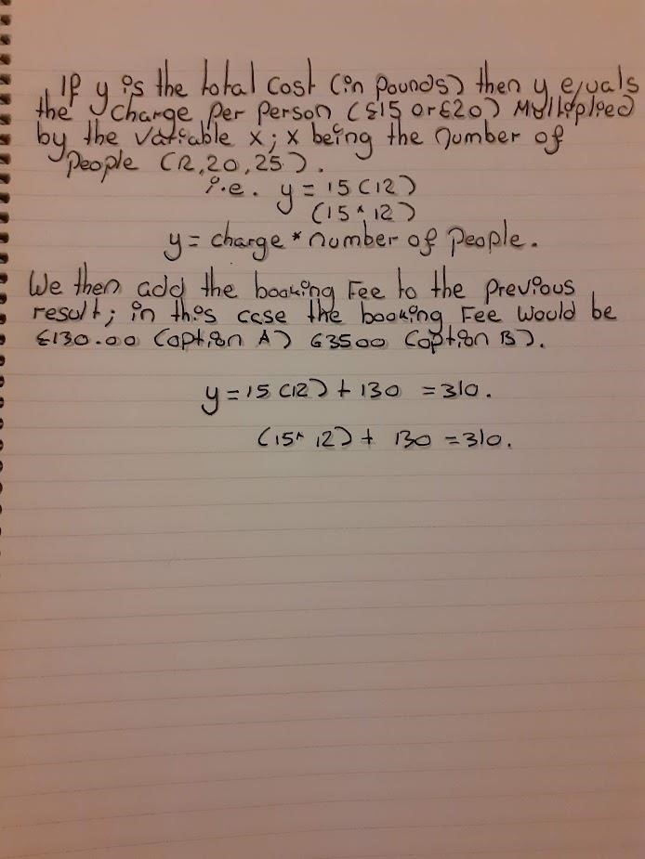

incorrect symbol

Which gives y = 15

*x*

+ 130

?

Note that demonstrations of

calculations are not required,

or helpful. This just shows a

result for

*x*

= 12. It doesn't

cover any other values. This

is why we need the general

description above, which

does cover all possible values

of

*x*

.



(ii)

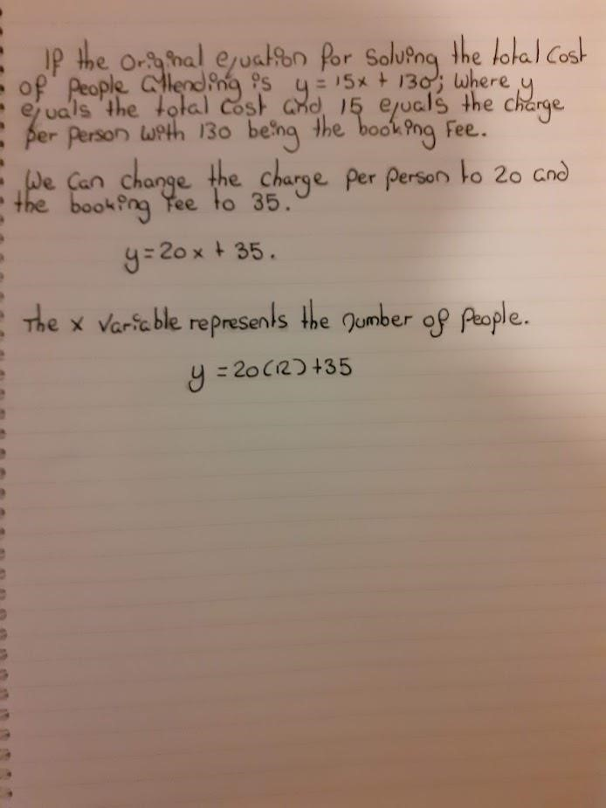

not required

(

c) (i)

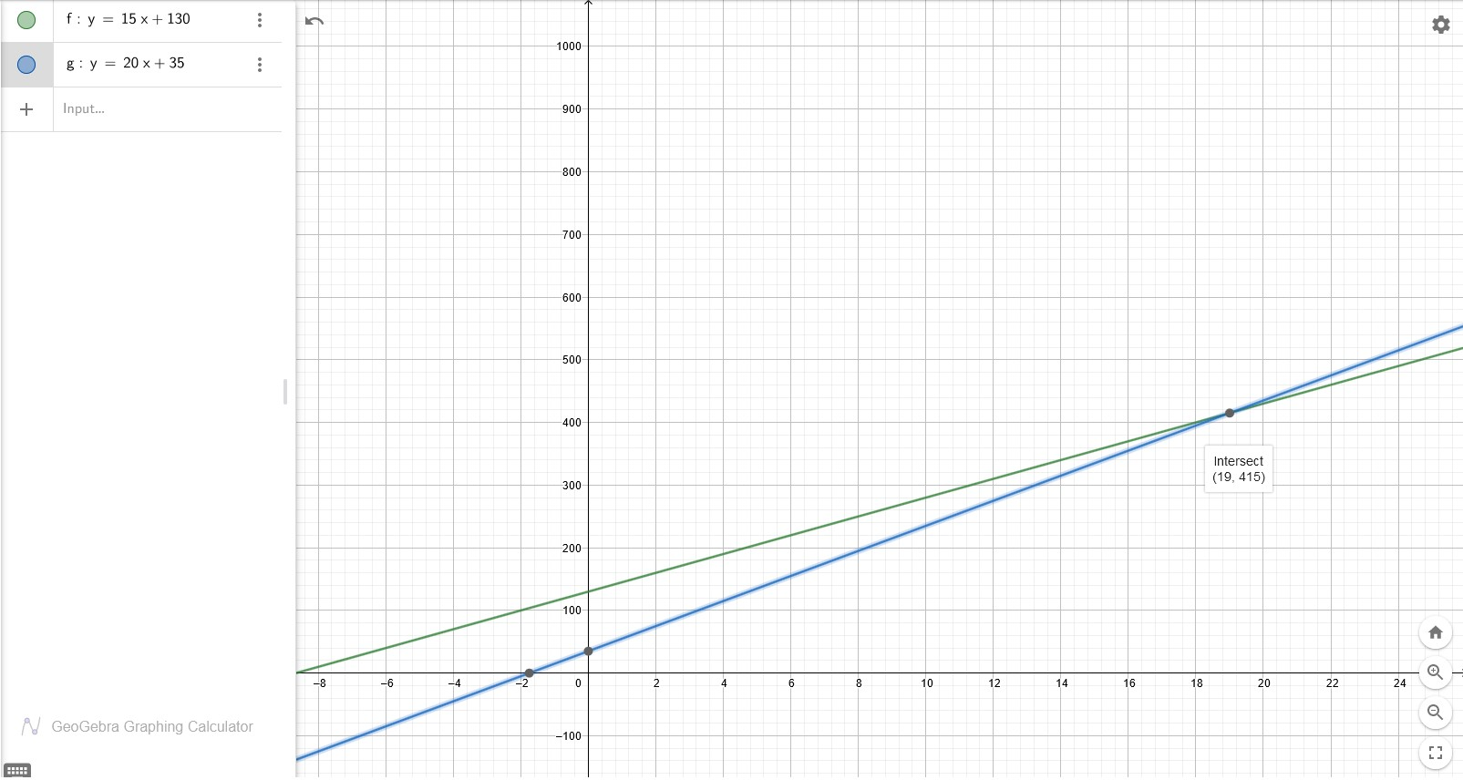

You were asked to use

Graphplotter or draw by hand.

(-1

).

mark

You need to be careful with the

limits of the graph.

I can't see the values for

*x*

= 25

on this graph, and your lines

should not extend below

*x*

= 0

(

since it is not possible to have a

negative number of people).

(-1

)

mark



(ii)

|  |
| --- |
| You need to typeset ALL of the maths. |

Green line: y=15x+130.

Blue line: y=20x+35.

The gradient of the line represents a positive slope with the green line showing a higher rate of cost at first; both lines become equal when the number of people is 19. Moreover, the blue line overtakes the green line thereafter indicating the cost is higher.

|  |
| --- |
| You needed to interpret the gradient in terms of the situation being modelled. You have described what the graph looks like, which isn't what was required.  The gradients in both cases represent the cost of entry per person.  [See Unit 6, Sections 2.3 and 2.4; Handbook, p.43] |



(2)

The y-intercept represents the overall cost of the equation, we can see from image below that the equation y=15x+130 (where x = 10) is equal to 280.

|  |
| --- |
| The y-intercepts are where the graphs cross the y-axis. Therefore, the y-intercepts represent the fixed cost of the booking fee. That is, the cost when no people attend. |



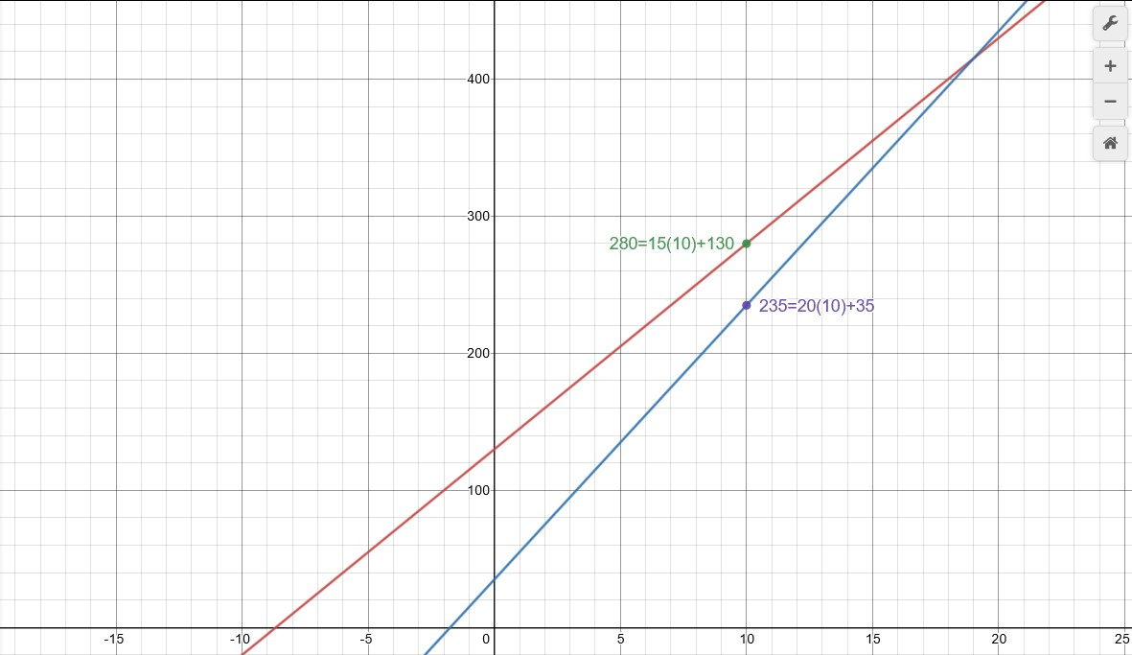

(d)

The intersect is (19, 415)

.

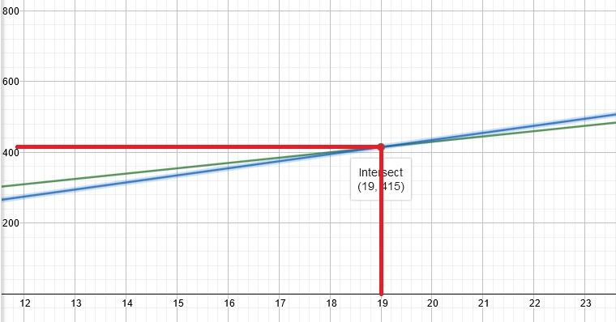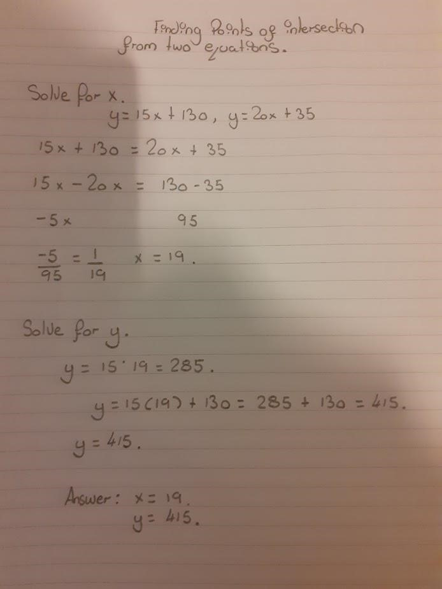

point of intersection

Fair enough, but you needed to say what this represents

too.

It is the point at which the cost is the same for both

Options with the same number of people attending.

mark

)

(-1



since both LHS are y, we can equate the RHS

=

Is this all one equation or two separate

equations? Please write equations on separate

lines. Where is the

*x*

in the first equation?

This is very puzzling. You haven't said which

equation you are using to find a value for y.

And you have said that y is equal to both 285

and 415. It can't be equal to both. (-1 mark)

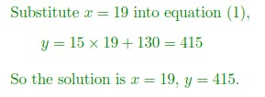

(1)

(2)

Label the equations

so that we can refer

to them easily later

So the solution is



At this point, it is a good idea to check by

substituting

*x*

= 19 into equation (2) to make

sure you get the same value for y.



(e)

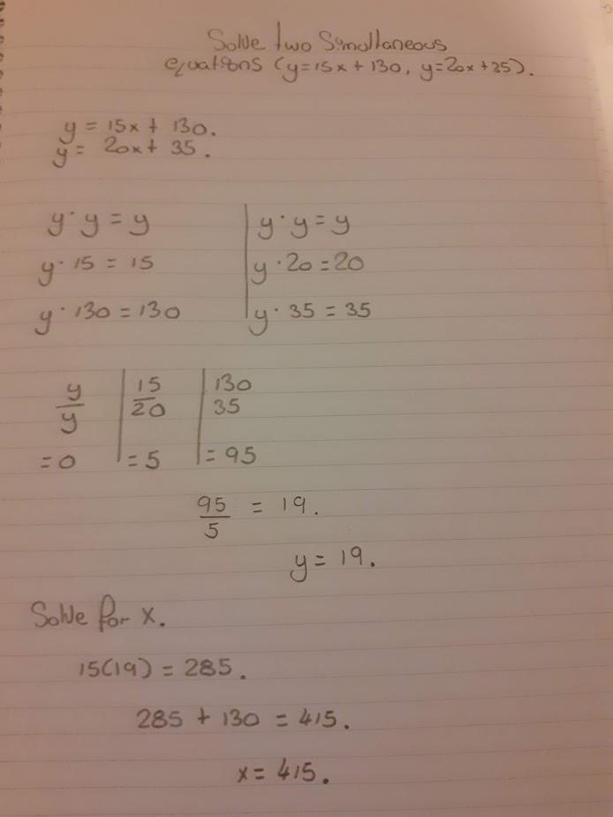

I have no idea what you are

doing here.

This is a page of

unexplained working,

resulting in the wrong

answer.

Incorrect notation and meaningless

equations.

I presume you are using a dot for

multiplication? If so, y x y = y

2

, not y.

The other working is wrong too.

No idea what you are

telling me here



(f)

For a low number of people option B would be a cheaper choice but if a large number of people are attending then option A would be a better choice.

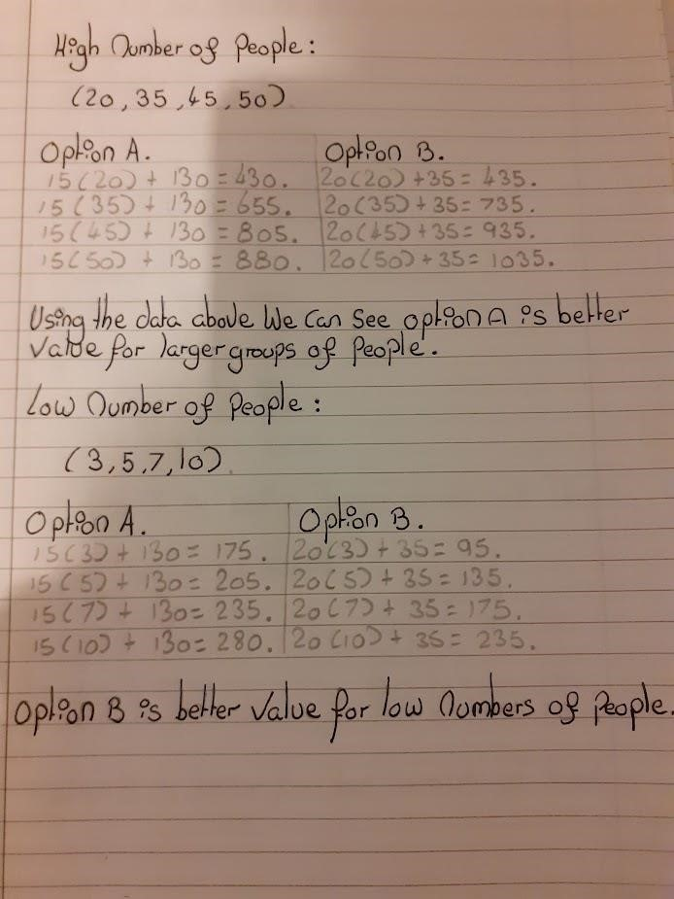

I don't need to see

calculations for varying

numbers of people. I

need an exact number of

people for which each

option is cheapest.

Never present

working by the side

of other working

Specifically:

For 18 people or fewer, Option B works out cheaper.

For 20 people or more, Option A works out cheaper.

For 19 people, the cost is the same.

Note that you didn't need any calculations as this information can be gleaned from the

intersection point.

[

32]

See Unit 7, p.197, Activity



(g)

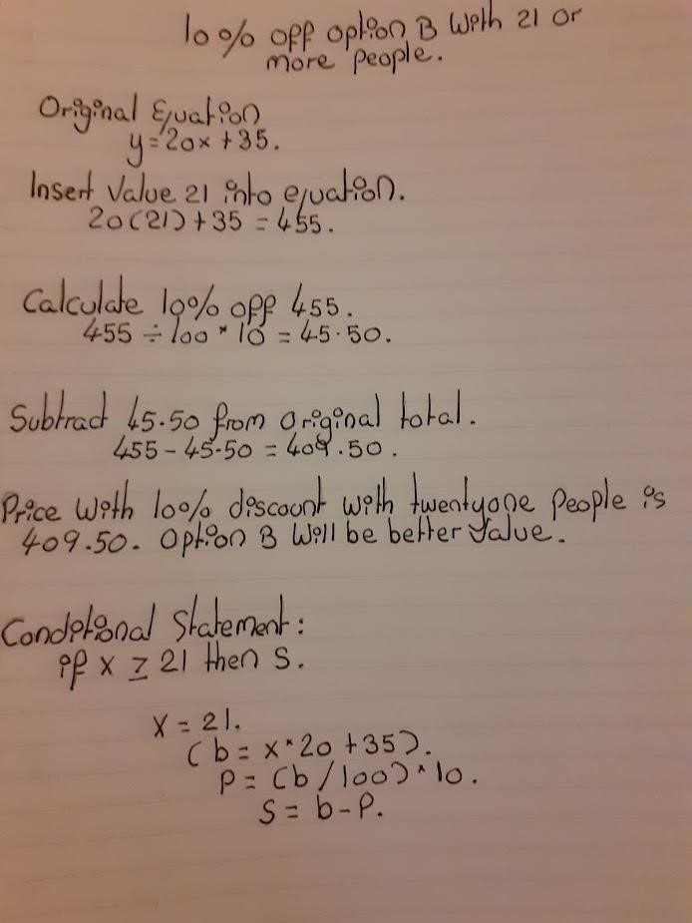

y =

When you substitute into the

equation, you must not lose

the left hand side.

Amount of discount =



You have misunderstood

the situation. You have

discounted 10% from the

whole cost. But the

question says that the

% discount applies to

10

the entry cost only, not

the booking cost.

What is this? This seems to be

some kind of computer code.

However, you haven't said

what b, p or s represent, so

I've no idea what this means

(

and I'm a programmer

!).

Please leave computer code

out of maths assignments.

But what are you comparing it with? How much is it

for 21 people attending Option A?



See next page for correct solution

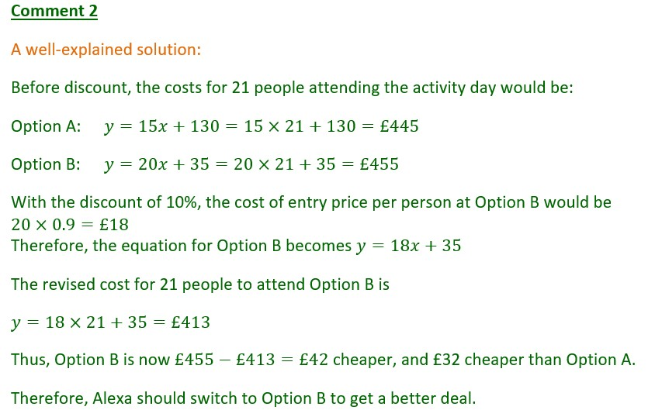

Question 5

i)

(

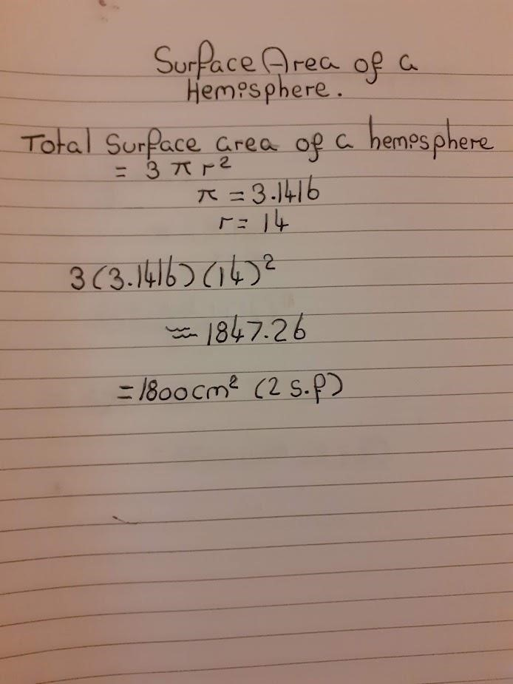

No.

❐

is NOT equal to this

number. Never

approximate

❐

. Use the

❐

button on your calculator.

Surface area of

hemisphere =

Start with WHAT you

are finding a value for

Write a conclusion!

-0.5

for approximating

❐

.

-0.5

for no conclusion.

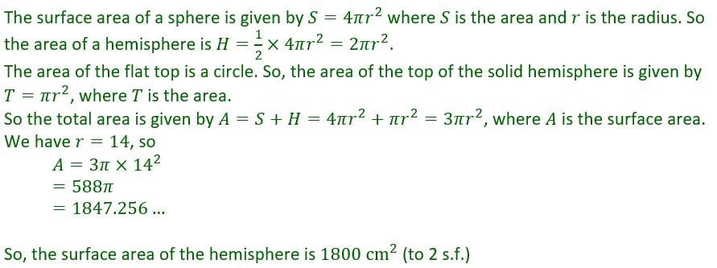

(a)

(

ii)

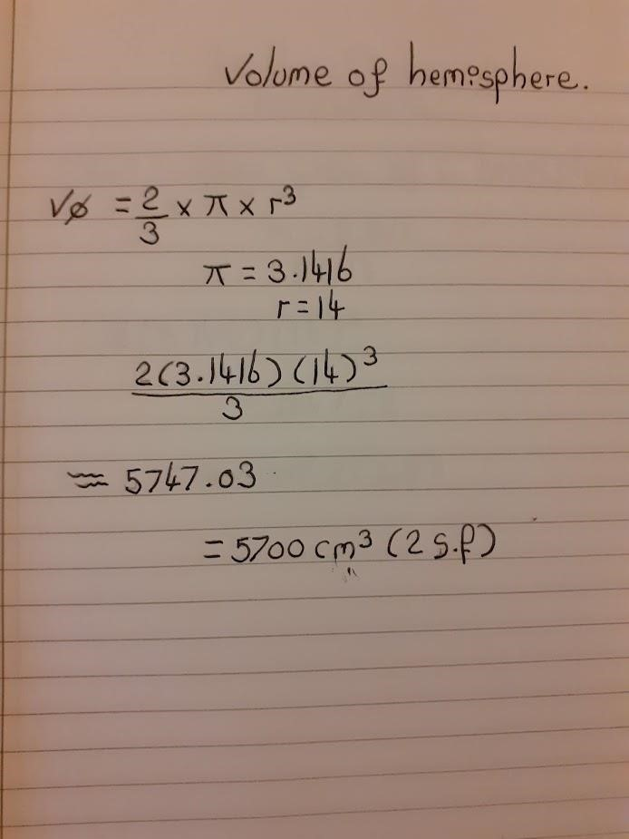

Undefined variable.

What is this?

Volume of the

hemisphere =

-0.5

mark for approximating

❐

;

-0.5

mark for no explanation of

what your answer represents.

Where is your conclusion?

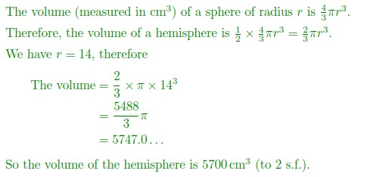

iii)

(

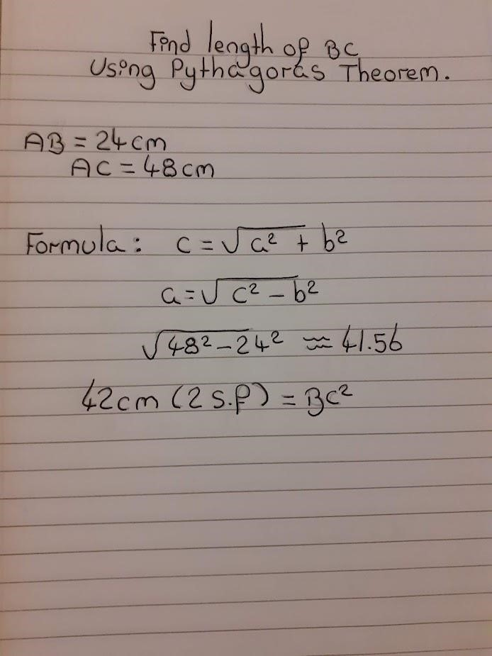

Pythagoras' Theorem states

a, b and c are undefined.

So, you need to say what

they represent. Much better

to write the whole solution in

terms of the symbols in the

question. Then we know

what you are talking about.

*a*

=



No. BC

2

is not 42cm (to 2 s.f.). BC is 42cm. (to 2 s.f.)

(-0.5

)

mark

This is an

approximation. You

need to give the full

answer.

Always start with

WHAT you are finding

a value for. Never just

write a sum

Better:

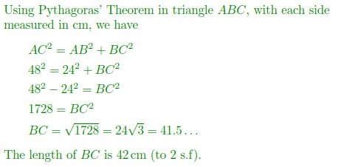

(iv)

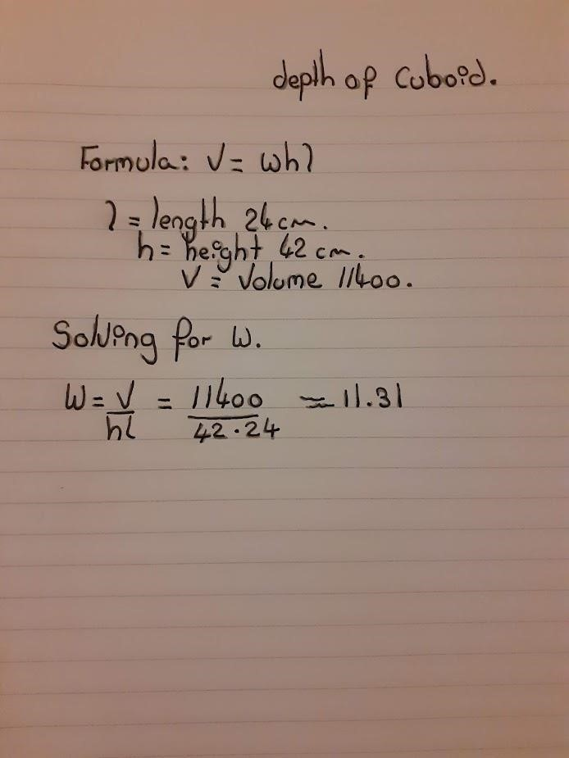

The word 'formula' gives very little

clue to what this represents or what

the variables are. You need more of

an introduction, with definitions.



No. You must never

use rounded values

in calculations.

Explain what you are working out

and what your reasoning is.

Volume of what? This

seems to be rounded

as well

Look at this without looking

at the question. What have

you found a value for and in

what units? What is the

accuracy of your answer?

You've given no

explanation.

But I don't know

what w is

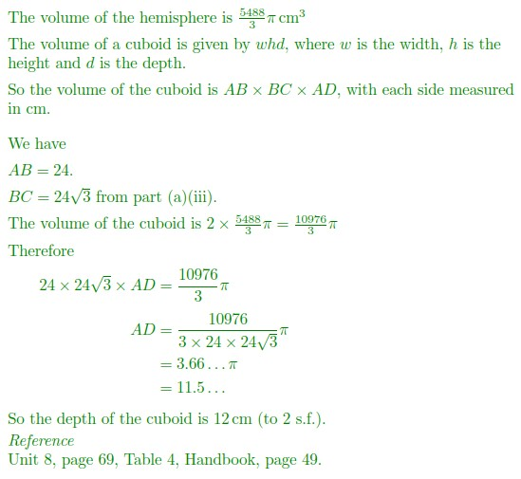

-1

for no explanation;

-0.5

for no conclusion

with correct units;

-0.5

for using rounded

values in calculations;

-0.5

for incorrect

rounding



b)

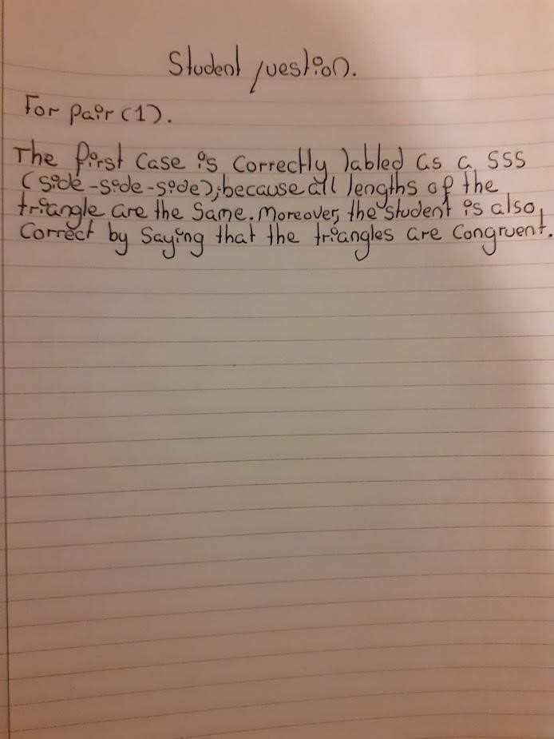

I think you mean that the

lengths of the sides in the

first triangle are equal to

the lengths of the sides in

the second triangle?



(b)

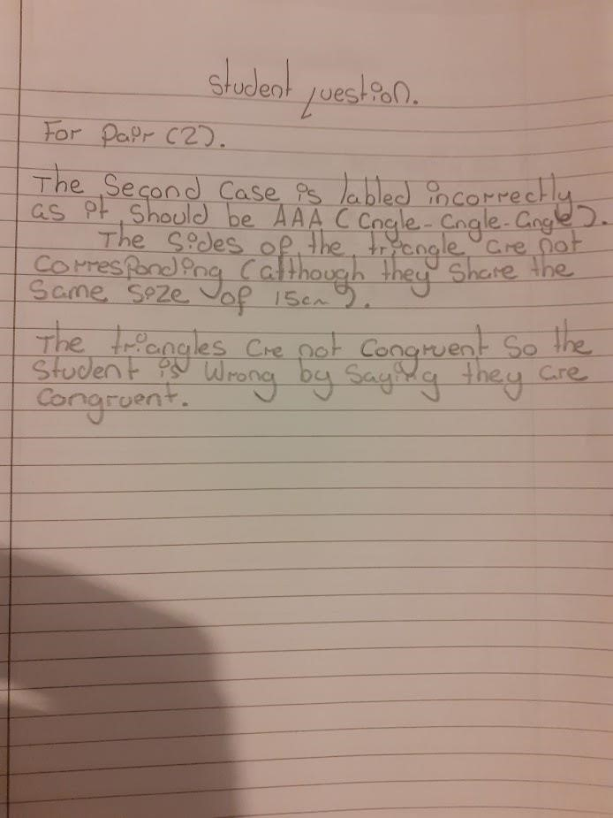

I'm not sure what you mean by labelling, as the 'AAA' case is a test of

whether the triangles are congruent on that condition (i.e. all angles are

the same). It isn't a label. Note that the AAA case would tell us that the

triangles were similar, but not necessarily congruent.

You need to point out that the angles are the same, but the side of 15cm

is not between the same two angles in each triangle. So, the triangles

are not congruent by ASA.



(c)

(i)

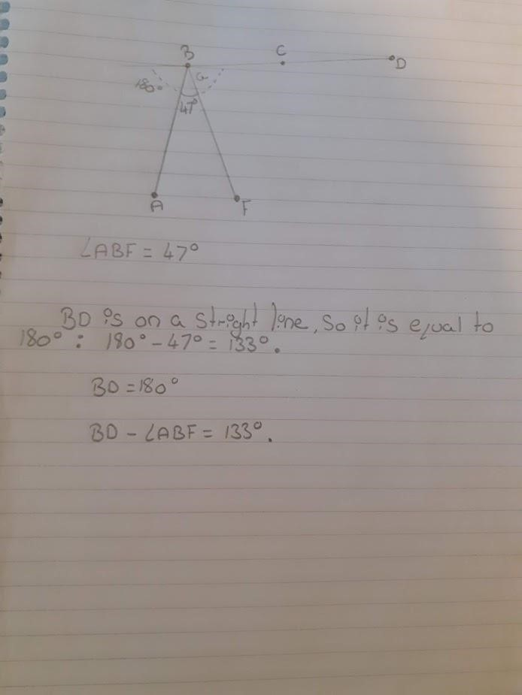

BD IS a straight line. It is not an

angle, so can't be 133

o

.

You haven't worked out the value

of angle



, which is what you

were asked for.

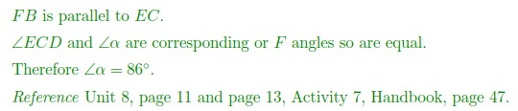

(ii)

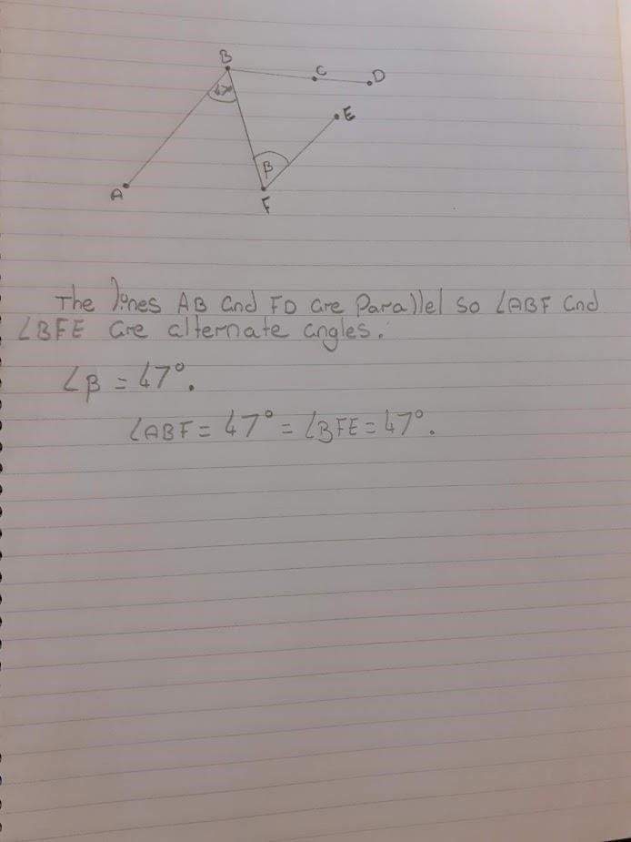

and, therefore, equal

This is the conclusion, so it should

come at the end.



(

iii)

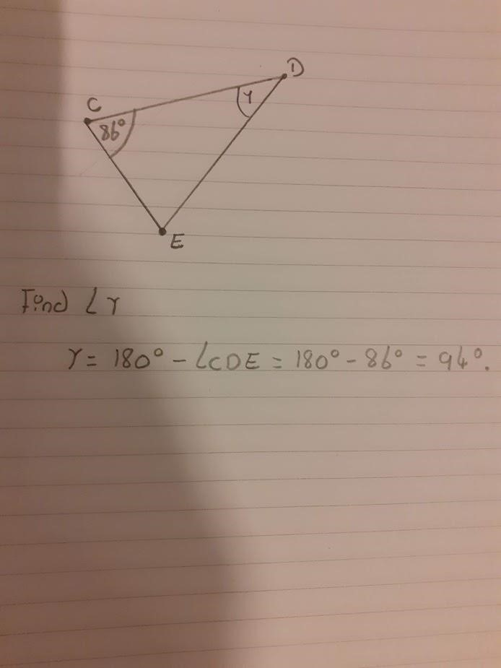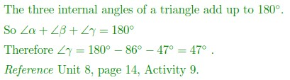

But



IS angle CDE.



(iv)

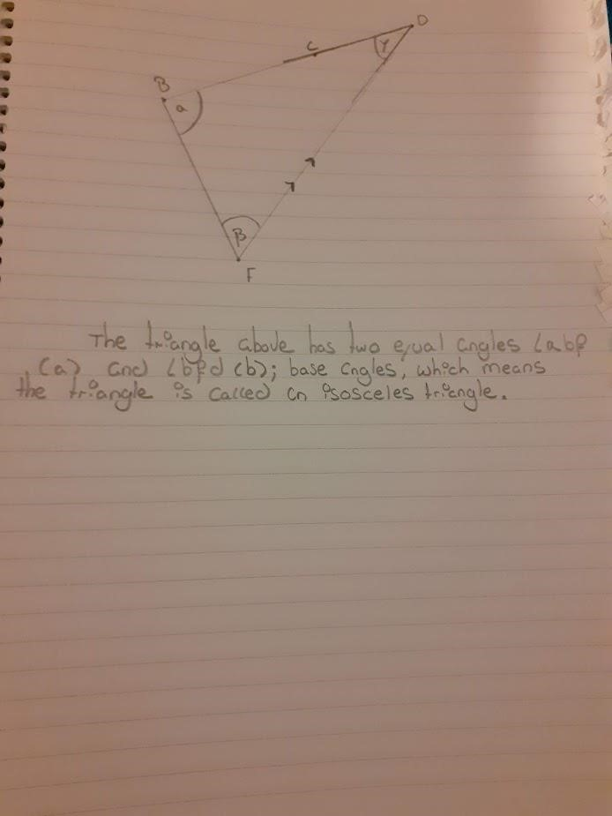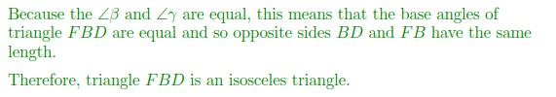

You need to say that the sides are equal too.

(-0.5

).

mark

Be careful to use correct notation.



Question 6

(a)

(i)

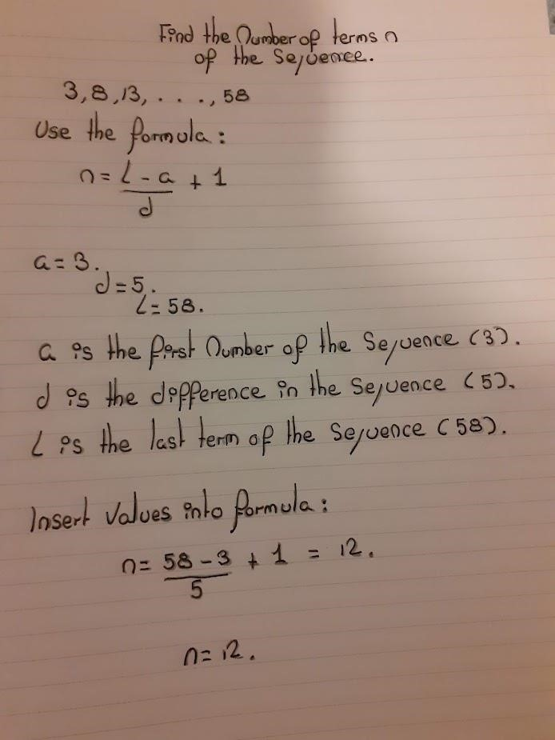

The number of terms, n, is given by



You were asked to check your

answer. To do this, write down all

the terms in the sequence and count

them. (-0.5 mark)

O.K., so you have a value for n. So what does this

represent? You need a conclusion. If you look at

your answer carefully, you don't say what n is at

any point.



(ii)

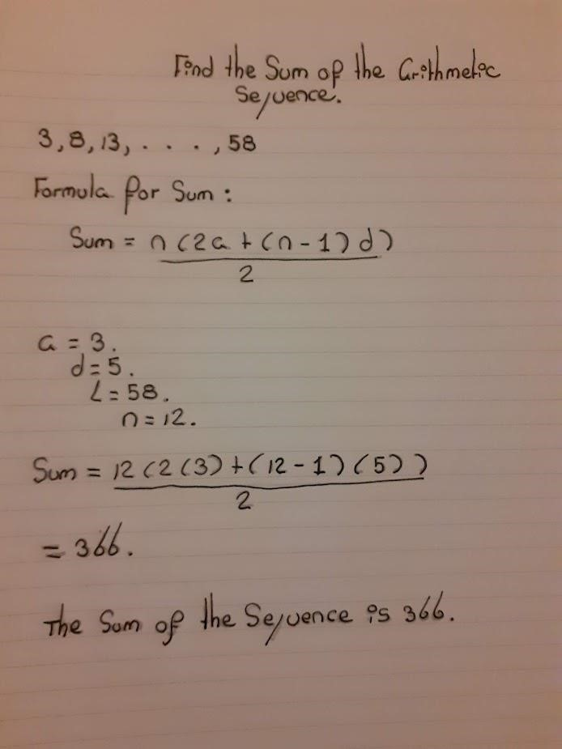

(

b)

(

i)

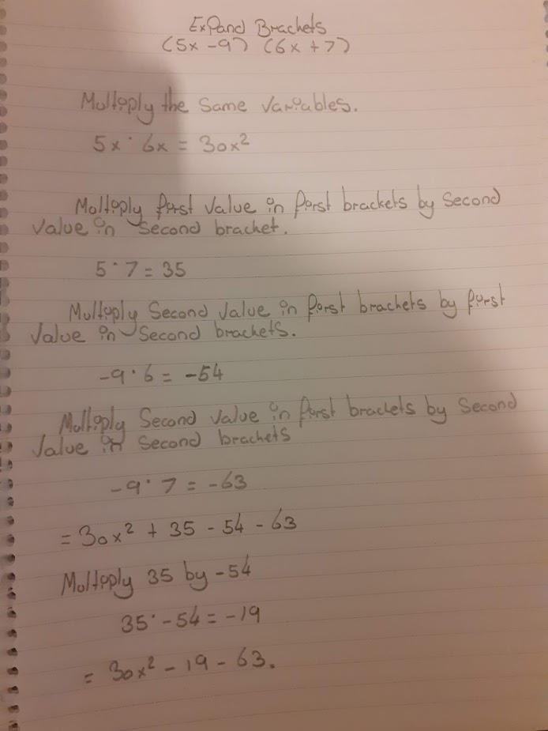

You should not split up the

multiplication into separate terms.

It is easy to make mistakes with

signs if you do this.

You should not describe

mathematical operations. Instead,

keep the whole expression

together and link equal

expressions with equals signs.

Do not use a dot for

multiplication

If you start with an equals sign, you are saying

this is exactly equal to the last thing you wrote

on the line above. As that was -63, this is a

misuse of the equals sign.

Misuse of equals

sign. This expression

is not equal to -19



Better:

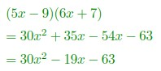

-19

*x*



(ii)

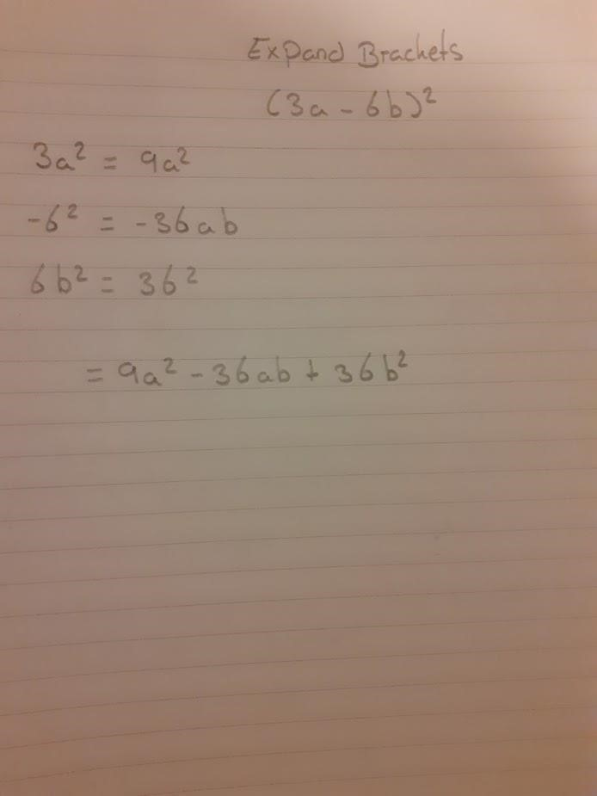

This cannot be true.

This can't be true either

What is on the left of this equals sign?



Better:

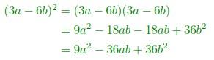

c)

(

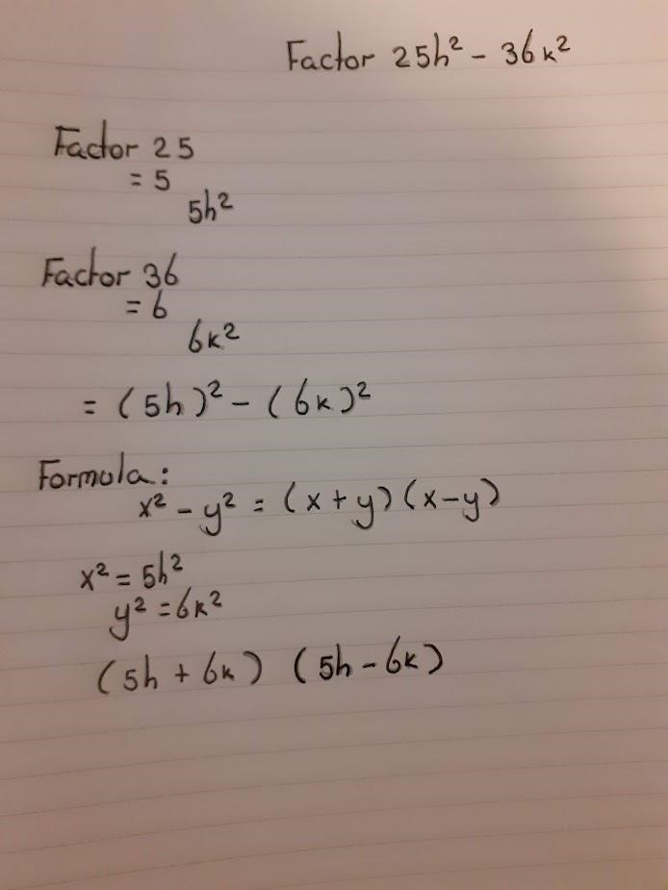

What is this equal to? It

isn't equal to 5 or 25.

You have equated 5

to 25. This is untrue

is not equal to

36

6

What is this equal to

But this is not equal to 6

*k*

2

Formula for what?

What is this equal to?



Better:



(d)

(i)

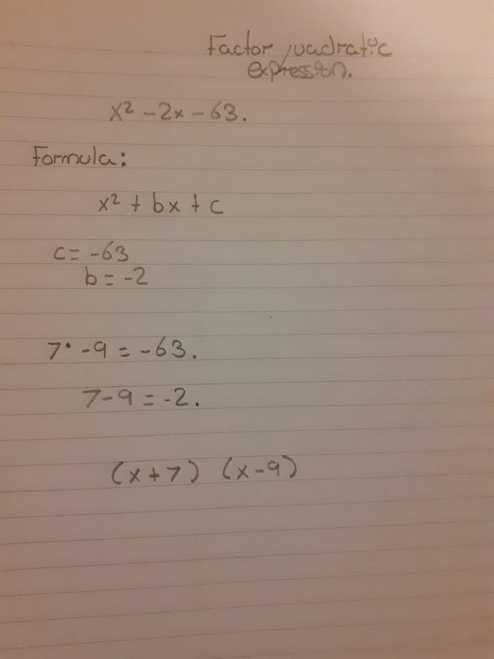

This is not a formula.

This is an expression

But what is this equal to?



Page Blank for Tutor Comments.

(ii)

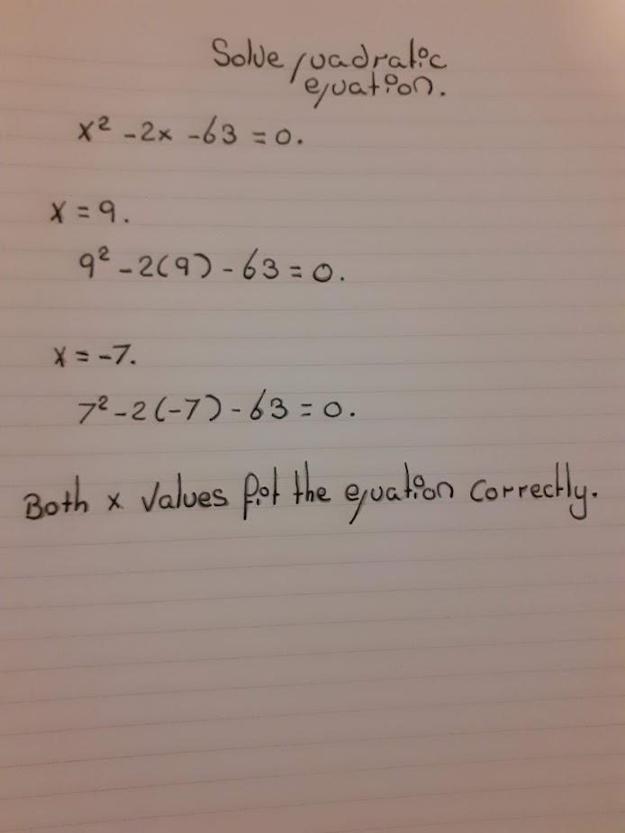

What is this

equivalent to?

You have not solved the

equation. You have just included

the checks on the solutions, but

you haven't shown how you got

those solutions in the first place.

(-1

)

mark



When

When

as required

as required

**Check**

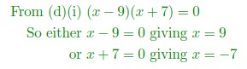

Missing solution

See Unit 9, p.115, Example 7

and Activity 21; Handbook p.50



Blank Page for Tutor Comments.

Page **78** of **87**

(e)

(i)

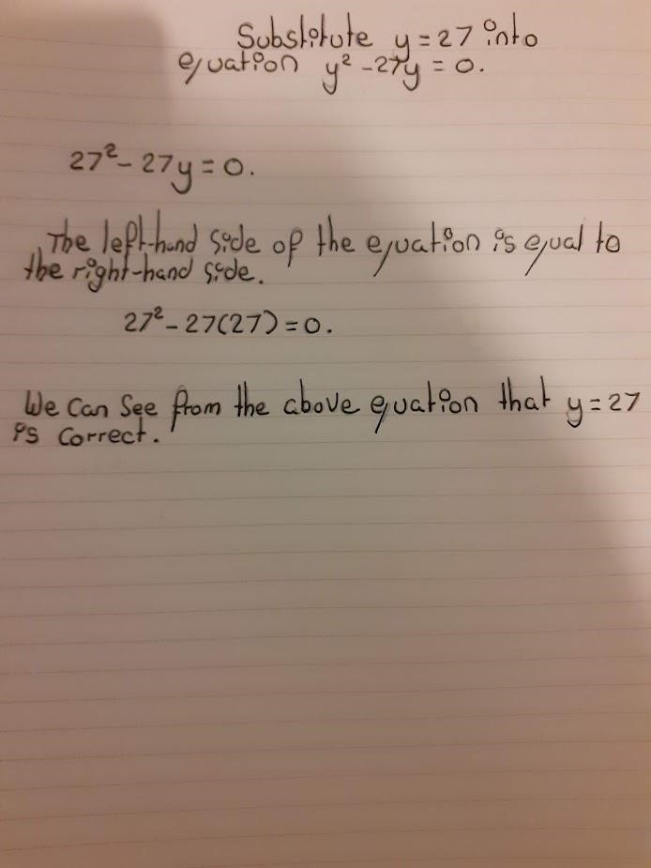

You need to demonstrate that you are just substituting into the left-hand side.

To check a solution, you need to work out each side separately, then compare

them and reach a conclusion. See Unit 5, p. 41 - 42, Examples 18 and 19

Correct solution:

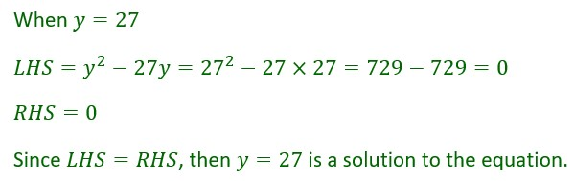

(ii)

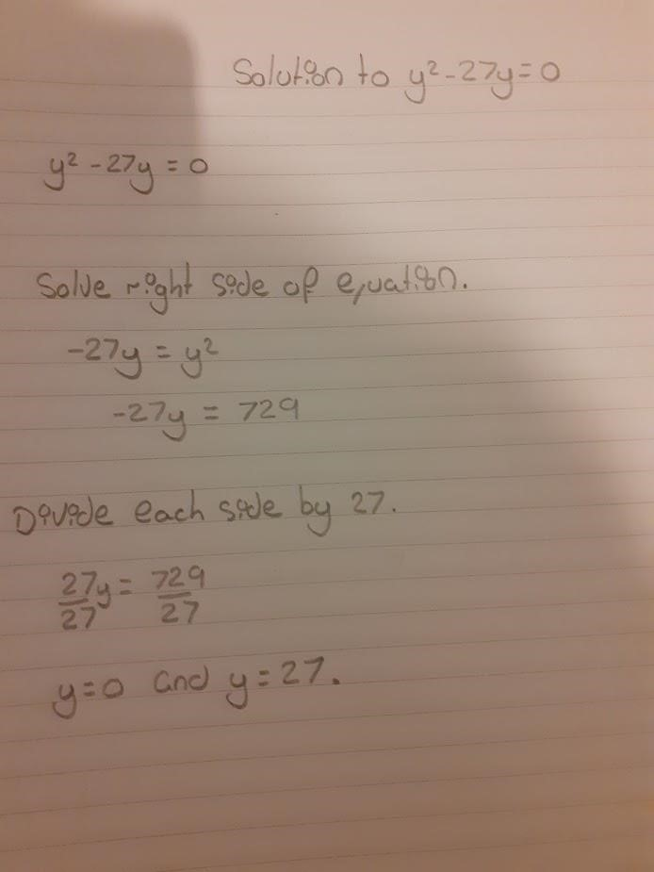

You can't solve just one side

of an equation. One side of

an equation is an expression,

which can't be solved. Solving

an equation means finding

values for the variable(s).

This is incorrect. I think you meant to add 27y to

both sides. If so, the LHS should be positive

where did you get 729 from? Bear in

mind that you don't know the value of

y at this point

This does not follow from your

working. Your working just leads

to the one solution. You wouldn't

get y = 0 from this working.

(-1

)

mark for incorrect working

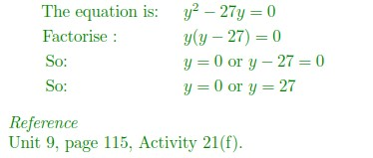

(iii)

|  |
| --- |
| But you haven't explained why their working only leads to one solution.  You are right that there should be two roots, but you need to explain why. |

If the problem is a quadratic equation there must be two roots; the student has only written one which is printed as y=27. Moreover, if the answer is to be correct the student should have written the following y=0 and y=27.

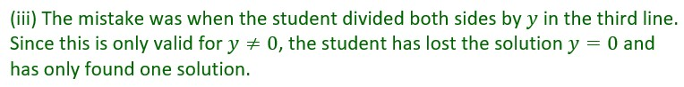



(f)

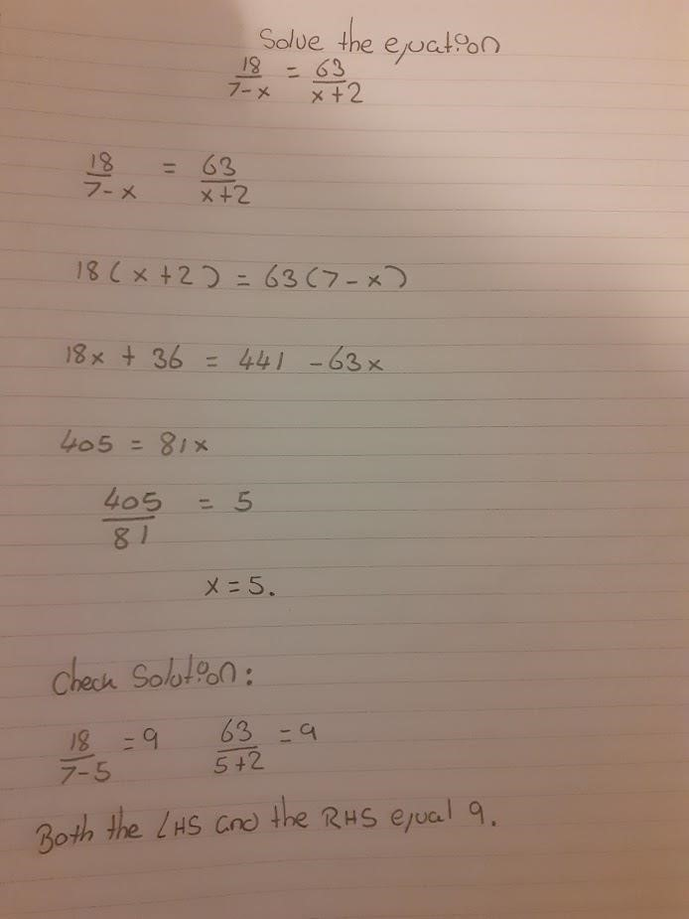

These are two separate calculations, so

should be on separate lines. Each one

needs to start with WHAT you are finding a

value for. How do we know that one is the

LHS and the other is the RHS?

O.K., so what does that

mean? Is your solution

correct or not?



Question 7

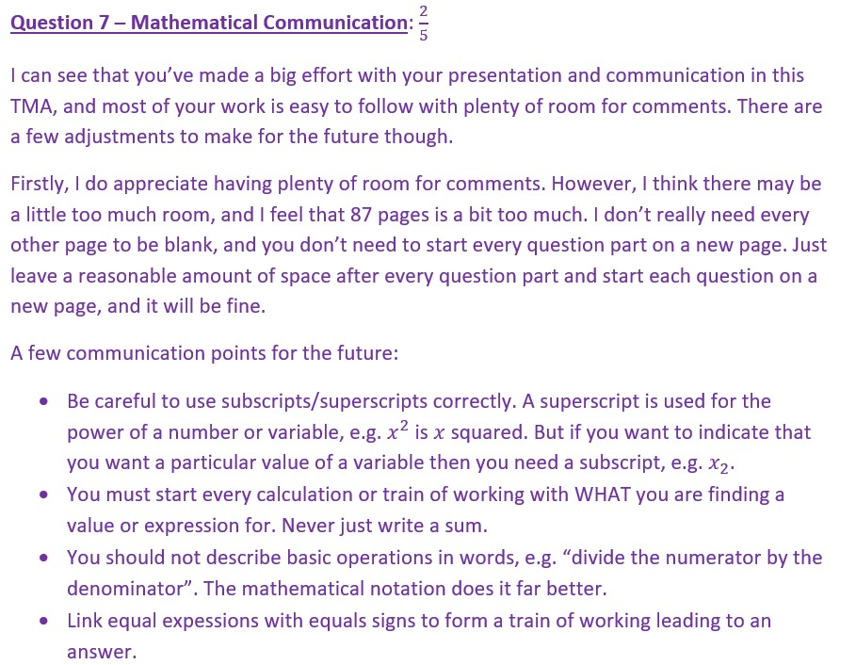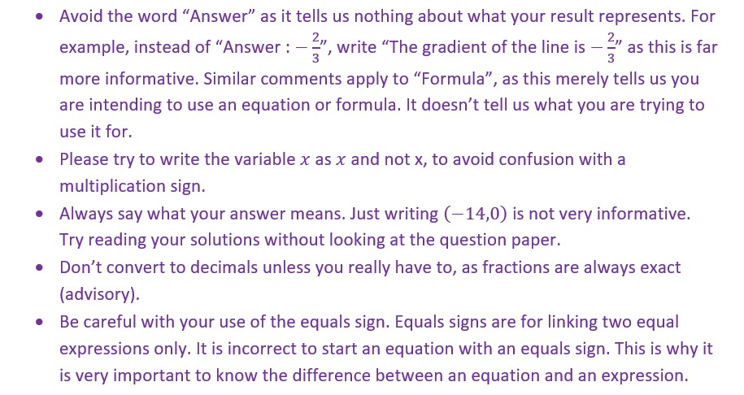

Continued on next page

